

Lab Experiment – 10
A Search Algorithm

Aim
To implement the A* search algorithm in Python to find the shortest path from a start node to a goal node.

Objective
To find an optimal path between two nodes by using the actual path cost and a heuristic estimate.

Algorithm
- Start with the initial node.
- Set the cost of the start node as 0.
- Calculate the evaluation function:
f(n) = g(n) + h(n)
  - g(n) = actual cost from the start node to node n.
  - h(n) = estimated cost from node n to the goal.
- Add the start node to the priority queue.
- Select the node having the lowest f(n) value.
- If the selected node is the goal node, display the path.
- Otherwise, generate its neighboring nodes.
- Calculate the cost for each neighbor.
- Add or update the neighbors in the priority queue.
- Repeat until the goal is reached.

FlowChart
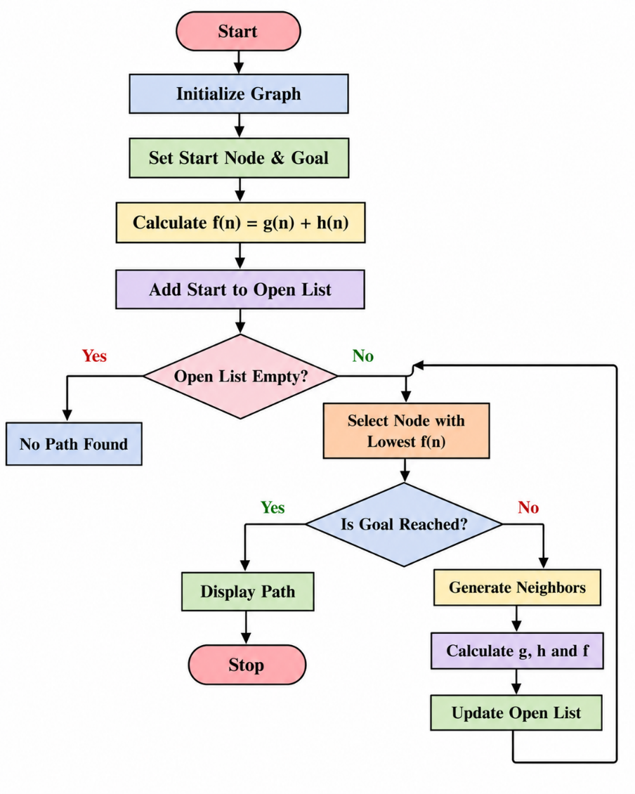
Code
import heapq

def a_star(graph, heuristic, start, goal):
open_list = []
heapq.heappush(open_list, (heuristic[start], 0, start))

came_from = {}
g_cost = {start: 0}

while open_list:
f, current_g, current = heapq.heappop(open_list)

if current == goal:
path = []

while current in came_from:
path.append(current)
current = came_from[current]

path.append(start)
path.reverse()

return path, g_cost[goal]

for neighbor, cost in graph[current]:
new_g = g_cost[current] + cost

if neighbor not in g_cost or new_g < g_cost[neighbor]:
g_cost[neighbor] = new_g
f_cost = new_g + heuristic[neighbor]

came_from[neighbor] = current
heapq.heappush(
open_list,
(f_cost, new_g, neighbor)
)

return None, float('inf')

graph = {
'A': [('B', 1), ('C', 4)],
'B': [('D', 2), ('E', 5)],
'C': [('F', 3)],
'D': [('G', 3)],
'E': [('G', 1)],
'F': [('G', 2)],
'G': []
}

heuristic = {
'A': 6,
'B': 5,
'C': 4,
'D': 3,
'E': 1,
'F': 2,
'G': 0
}

start = 'A'
goal = 'G'

path, cost = a_star(graph, heuristic, start, goal)

if path:
print("Shortest Path:", " -> ".join(path))
print("Total Cost:", cost)
else:
print("No Path Found")

OUTPUT
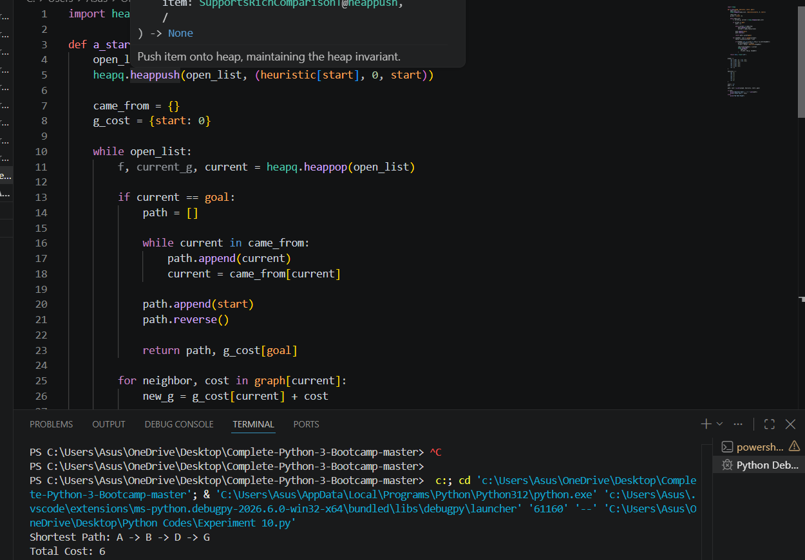

Result
The A* search algorithm was successfully implemented in Python and the shortest path from the start node to the goal node was obtained.

Conclusion
The A* algorithm finds an optimal path by combining the actual cost g(n) and heuristic cost h(n) using f(n) = g(n) + h(n). It is widely used in pathfinding and navigation problems.

